

Enterprise Storage

**WFA Deployment Guide**

**Synopsis:** The Thomson Reuters Storage Administrators guide to deploying, updating and managing the Netapp Workflow Automation Tool, WFA.

**Authors:** David Ellis

**Contributors:** [Contributors]

**Document Version:** V0.1

**Date:** 1/12/2015

**Document Status**: Draft

Document Location: [Hyperlink to this documents location]

**CONFIDENTIAL INFORMATION**

This document contains information proprietary to Thomson Reuters and may not be reproduced, disclosed or used in whole or part without express permission of Thomson Reuters.

© Thomson Reuters 2015

Contents

1 Introduction 3

1.1 Management Summary 3

1.2 Assumptions 3

1.3 Document References [Change below as appropriate] 3

1.4 Change History 3

1.5 Distribution List 3

1.6 Glossary 3

2 WFA Deployment Guidelines 4

2.1 Virtual Server Requirements 4

2.1.1 Minimum Required Software 4

2.2 Standard WFA Version 4

2.3 Standard WFA Ports 4

3 Installation Instructions 5

3.1 Obtain WFA from Netapp Now 5

3.2 Ensure .Net Framework 3.5.1 has been enabled on the Server 5

3.3 Install Windows Management Framework 3.0 6

3.4 Install WFA Instance 6

4 Level- Setting new WFA instances 10

4.1 Take a backup of existing up to date WFA instance. 10

4.2 Copy WFA Database Key 10

4.3 Restore New WFA instance with backup 10

5 Updating Existing WFA instances. 11

# Introduction

## Management Summary

The Workflow Automation, WFA, is a tool developed and maintained by NetApp which allows for an organization to automate storage tasks. This document will outline the physical requirements for the virtual server, installing, updating, and maintaining WFA.

## Assumptions

This document assumes the reader is conversant with NetApp technologies, as well as basic windows server principles, including application installation and server role management.

## Document References [Change below as appropriate]

|  |  |  |  |  |
| --- | --- | --- | --- | --- |
|  | **Document Name and URL** | **Version** | **Date** | **Author** |
| 1 | [Installation and Setup Guide](https://library.netapp.com/ecm/ecm_download_file/ECMP1397247) | x.x | May 2014 | NetApp, Inc |
| 2 | [KB104155](https://kb.netapp.com/index?page=content&id=1014155&actp=LIST_POPULAR) | 3.0 | 06/24/2014 | Netapp Inc |

## Change History

|  |  |  |  |
| --- | --- | --- | --- |
| **Ver** | **Date** | **Author** | **Key Changes** |
| 0.1 | 1/12/2015 | David Ellis | [First Draft] |

## Distribution List

|  |  |
| --- | --- |
| **Name** | **Role** |
| DCO-Storage-Services | DCO Storage Services Team |
| Brett Truhler | Storage Architect |
| Troy Lykken | Storage Engineering Manager |

## Glossary

|  |  |
| --- | --- |
|  |  |
|  |  |

# WFA Deployment Guidelines

There will be two WFA instances for each of the following data centers, Eagan, Docklands, Plano, Hazelwood and Singapore. These WFA instances will manage CIS/CPS data sources in each respective environment. WFA instances should also be deployed in the MGMT domain with administrative access assigned to the storage group MGMT\REST-StorageSupportServerAdmins

WFA will be installed on 64-bit Microsoft Windows Server R2 SP1

|  |  |
| --- | --- |
| Component |  |
| CPU | 2.27 GHz or faster, 2 Core, 64 Bit |
| RAM | 4 GB |
| Free Disk Space | 30 GB |

### Minimum Required Software

* Supported Browsers
  + Mozilla Firefox
  + Google Chrome
  + Microsoft Internet Explorer
* Powershell V 3.0 – Required for integration with Manila Driver
* Windows Management Framework 3.0
* Microsoft .Net Framework 3.5
* Heidi SQL
* Trend Micro

## Standard WFA Version

The current standard version of WFA will be 2.2.1 RC1. All new and existing deployments should be loaded with this version, especscially if interfacing with manila for openstack provisioning is a requirement. This section should be updated as new versions have gone through a vetting process.

## Standard WFA Ports

|  |  |
| --- | --- |
| HTTP | HTTPS |
| 27900 | 443 |

# Installation Instructions

## Obtain WFA from Netapp Now

The appropriate WFA version can be downloaded from the NetApp Now site, [OnCommand Workflow Automation 2.2.1 RC1](http://mysupport.netapp.com/NOW/download/software/ocwfa/2.2.1RC1/WFA-x64-V2.2.1.0.0RC1-B2508934.exe). It should then be copied to the local drive on the appropriate server.

## Ensure .Net Framework 3.5.1 has been enabled on the Server

Engineers can verify that the framework has been enabled through the Server manager interface within the features section.

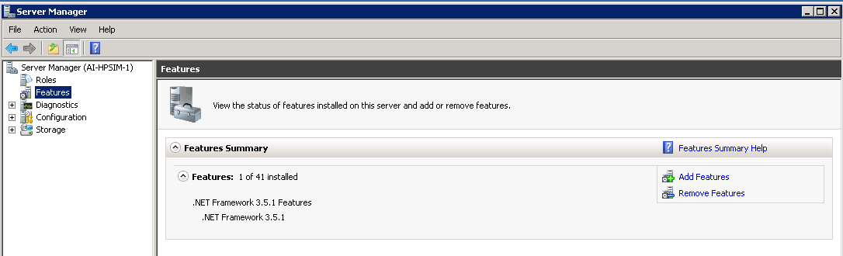

If it is found that the framework has not been enabled, clicking the add feature option, select the .Net Framework from the available features and click install. The server will require a restart.

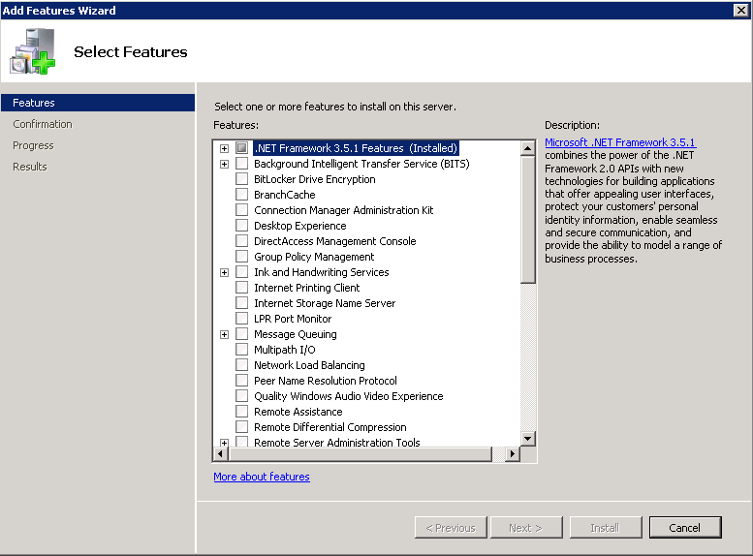

## Enable PowerShell ISO feature

The upgrade instructions for PowerShell include enabling the ISO PowerShell feature. To complete this activity, navigate to server manager.

## Install .Net Framework 4.0

## Install Windows Management Framework 3.0

PowerShell V3 is packaged as part of the Windows Management Framework 3.0. The user can check what current version of PowerShell is running by executing the command “get-host” from the PowerShell command prompt. If an update is required, the appropriate package can be downloaded, [Windows Management Framework 3.0](http://www.microsoft.com/en-us/download/details.aspx?id=34595). There are two different versions of the update depending on the which service pack has been deployed on the server. They are as follows:

* Windows Server 2008 R2 SP1

64-bit versions: Windows6.1-KB2506143-x64.msu

* Windows Server 2008 Service Pack 2

64-bit versions: Windows6.0-KB2506146-x64.msu

The server will require a restart after the update package has been installed.

## Install WFA Instance

Double click the downloaded version of WFA. After the wizard has opened click next and accept the license agreement.

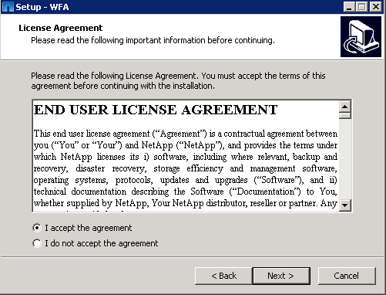

Define the appropriate ports for WFA utilization, sec 2.3, click next.

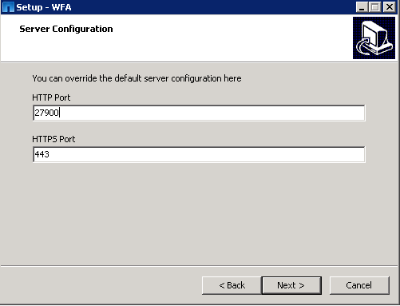

If PowerShell and .Net framework are not found on the server the installer will prompt for the user to make the appropriate downloads.

The installer then prompts for the user to input a Site Name and company name. The site name should correspond to the environment where WFA is being installed, i.e Singapore, DTC, etc, click next.

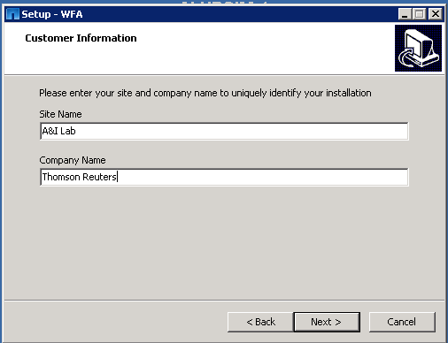

The Engineer should then define the administrative user per Thomson Reuter’s standards, click next.

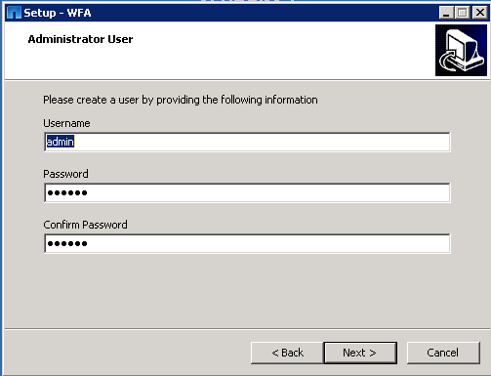

Finally the installer prompts for the user to verify the installation directory, click next after defining the appropriate location.

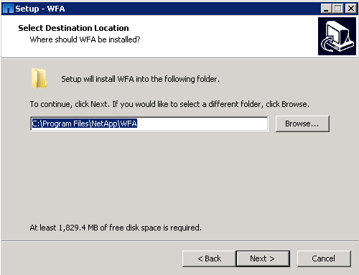

Click install to begin the WFA installation.

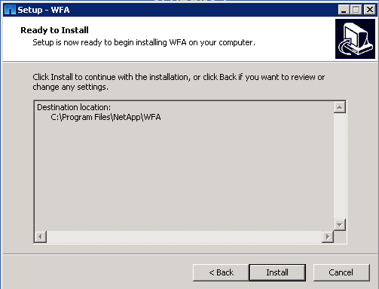

Once the installation has been completed, the server should be restarted.

Verify the WFA is available. Through a local browser access WFA.

http://<wfa_server_ip>:27900.

# Preparing WFA for utilization

## Define New Data sources

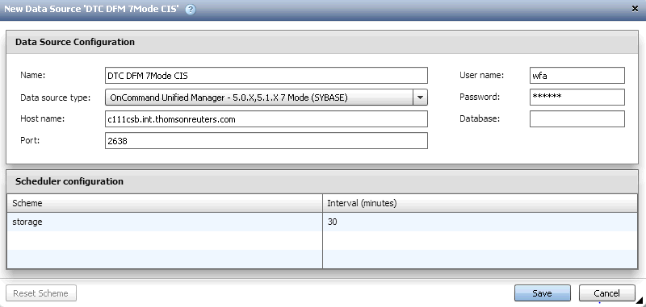

## Configuring LDAP

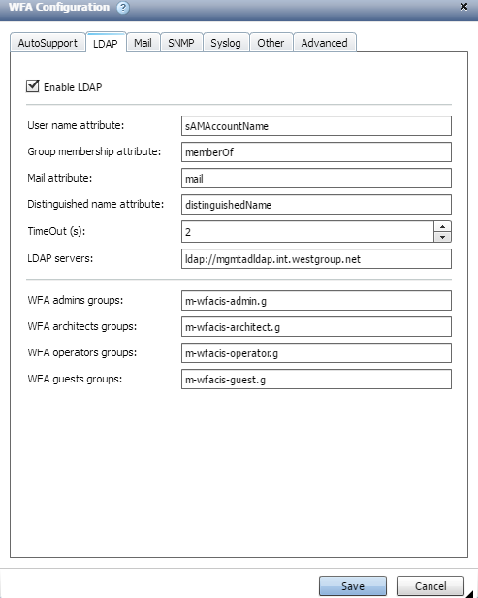

## Configuring Mail Settings

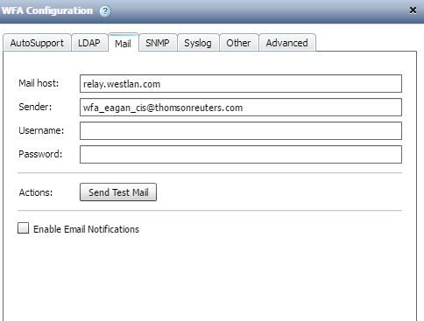

# Cloning WFA Instances

## Take a backup of existing up to date WFA instance.

From an active WFA UI session, Click Administration, select Backup & Restore

Click Backup, download begins automatically.

## 

## Copy WFA Database Key

Restoring a new instance from another wfa database requires the key from the primary WFA instance to be installed on the new wfa server.

On the primary server start a cmd session, navigate to c:\Program Files\Netapp\WFA\bin

Insert the following command wfa.cmd –key



Navigate to the same directory on the new WFA instance, define the wfa key utilizing the command, wfa.cmd –key=<wfa key>



## Restore New WFA instance with backup

Login as administrator to the new WFA instance, Click administrator, and then backup and restore.

Click choose file, select the backup taken of the up to date WFA instance.

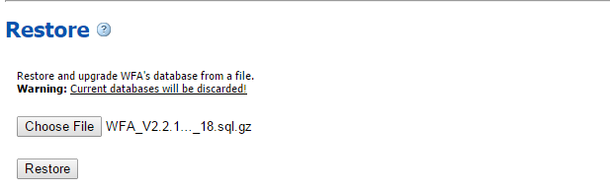

Click Restore.